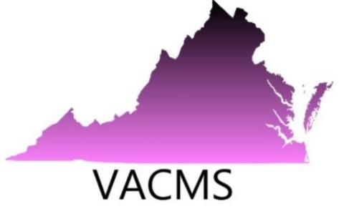
Virginia Council of Mathematics Specialists
2019 Annual Conference

October 4, 2019
University of Mary Washington Stafford Campus
121 University Boulevard
Fredericksburg, VA 22406

We are expecting over 200 presenters, mathematics specialists/coaches, and teacher leaders from across Virginia. Our theme this year is Coaching: Purposeful Planning for Visible Impact. John Almarode, author and mathematical education expert will be our keynote speaker. Vendors can contact Vickie Inge with questions at vickieinge@gmail.com.

Participating companies will be listed in the conference program along with their company logo. Vendors who wish to contribute items to be placed in participant’s bags or for prizes are welcome to send the items to Vickie Inge, vendor contact at 9818 Lees Mill Road, Warrenton, VA 20186.

Vendor Application Information

Please complete the following.

Company/Vendor:
Representative:
Cell Phone Number:
Email Address:
REQUEST FOR TABLE(s)
Please check the number of tables you are requesting for the conference. Only tables provided through the University of Mary Washington may be used for this conference.
□ One vendor table $150.00
□ Two vendor tables $200.00
Please email your completed application and company logo to:
Vickie Inge by August 31, 2019 at
vickieinge@gmail.com

Payment must be mailed to:
VACMS
Attn: Vickie Inge
9818 Lees Mill Rd.
Warrenton, VA 20186

A letter confirming your request and providing specific logistical information will be sent to you.

Thank you for helping support our members and our conference. VACMS looks forward to working with you!
a
Please email your completed application and company logo to:
Vickie Inge by August 24, 2018 at
vickieinge@gmail.com

Payment must be mailed to:
Vickie Inge
Attn: Virginia Council of Mathematics Specialists
9818 Lees Mill Rd.
Warrenton, VA 20186

Please email your completed application and company logo to:
Vickie Inge by August 24, 2018 at
vickieinge@gmail.com

Payment must be mailed to:
Vickie Inge
Attn: Virginia Council of Mathematics Specialists
9818 Lees Mill Rd.
Warrenton, VA 20186

