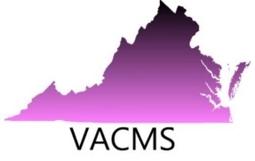
Now accepting Registration and Proposals for the 6th Annual Conference
Virginia Council of Mathematics Specialist
September 28-29, 2017 Conference
Germanna Community College
18121 Technology Drive, Culpeper, Virginia

Recalculating, Recalculating… Enhancing the Learning Journey
2017 Conference Goal

The goal of the 2017 VACMS conference is for mathematics specialists and teacher leaders to enhance their toolkit so they can support teachers to interpret the revisions to the Curriculum Framework, thus, supporting the implementation of Virginia’s 2016 Standards of Learning for Mathematics. In particular, ways to use learning progressions and the information in “Understanding the Standards” to recalculate instructional programs to enhance students’ learning journeys.
2017 Conference Strands

- Coaching for Effective Teaching: Enhance instruction with research informed teaching practices.
- Influencing Access and Equity: Engage diverse learners in high quality math programs and instruction.
- Enhancing Math Leaders’ Skills: Work with adults, facilitate PLCs and grade level meetings, evaluate curriculum materials and technology resources, and transition to the role of a math specialist.

Conference Registration Fee: $100. Off-site banquet dinner Thursday night at Peppers Grill $20
Register at: www.vacms.org
All payments must be received by September 20, 2017.
You may pay online or send payments to VACMS Registration Coordinator,
Jane Grove at 12716 Marsh Road, Bealeton, VA 22712.

